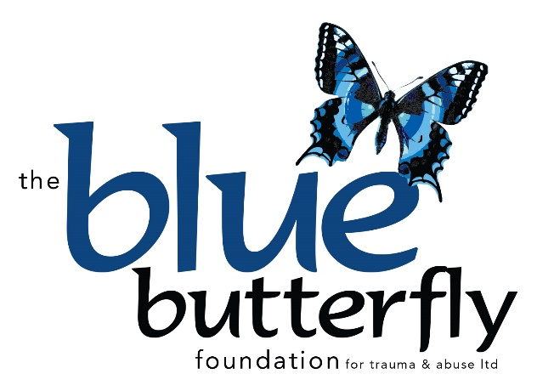
Directors Report
2021-2022

The Blue Butterfly Foundation for Trauma & Abuse Ltd (Formerly Gnadenfrei Foundation) is a Public Benevolent Society founded in 2006 to provide support and contribute to healing for people of all ages affected by Critical Incidents or Abuse.
The past two years of the Covid 19 Pandemic have been very difficult for Australians across the spectrum with increased instances of Domestic Violence, Cyber Bullying of both Children and Adolescents doing online study and isolation from repeated lockdowns leading to an increase in suicides.
Fundraising has also been significantly impacted by the Pandemic rules and lockdowns limiting the number of events we have been able to host to raise funds for the Foundation.
The Foundation has continued to provide support for clients suffering from trauma and needing additional therapy to recover with support to attend the sessions where needed. Telehealth became possible during the pandemic however this did not suit the needs of clients needing trauma therapy so face to face was preferred.
Our meal bank had to be suspended due to the difficulty in meeting strict covid requirements for vaccination status and also accessing food supplies during shortages.
Our grocery bank with produce provided by Oz Harvest continued to operate when they had supplies and we have developed a list of needy families who benefit from that support.
Areas of Trauma Reported
Personal Violence including Domestic Violence has been the most frequent trauma reported by Adults this year followed by Childhood or Sexual Abuse, Criminal Acts, Motor Vehicle Accidents, Industrial Trauma and Medical Trauma.
Children and Adolescents attending have been subjected to Bullying, Domestic Violence and Sexual Abuse.
A significant number of clients we support have experienced extreme abuse and neglect in childhood and an increasing number are presenting with undiagnosed Dissociative Identity Disorder (DID formerly MPD)
Assistance Provided
During the past financial year Blue Butterfly Foundation has continued to provide Therapy support.
A total of 166 Sessions were provided to 123 Adults,
66 Sessions were provided for 7 Children aged between 4-11 years and
52 Sessions to 4 Adolescents aged between 14-17 years.
Special Complex Trauma Fund
Specialized Trauma focused Therapy to 110 people who have Complex Trauma and Comorbid dependencies, extended therapy to assist their recovery to a value of $19,000.

Domestic Violence Grant $3000 (MBRC)
Our special project provided individual Trauma Therapy for 13 people as well as screening for risk and education in relation to Coercive Control, now recognized as a major factor in Domestic Violence homicides. This project runs till the end of June 2022.
Gnadenfrei Pty Ltd, our parent company (a separate entity), continues to support the Foundation by providing free office space as well as administrative support.
In addition, Gnadenfrei professionals, provided therapy to 102 clients who would meet criteria for Foundation assistance were the funds available. These clients have been Bulk Billed under Medicare at below the current low concession rate or seen pro bono to above the value of $7,114.00.

With the Pandemic restrictions easing and Adults well catered for, we are recognizing the need to increase our service provision to Children and Adolescents suffering Trauma from Bullying and Domestic Violence. We plan to make this a holistic experience for them with Individual Therapy followed by age-appropriate group programmes to help increase self-esteem, increase their social skills, and increase their resilience. We have had Adolescents we have been unable to help because their parents lack income to support the therapy they need and our funds have been inadequate due to our other areas needs.

Coral Palmer
Founding Director

